TO: FM: 汇利达国际货运有限公司
Shipper  UNITEX INTERNATIONAL FORWARDING (GUANGZHOU) LTD  ROOM 2511-2514,YINGLONG PLAZA,  NO.76 HUANGPU RD,W.GUANGZHOU,  P.R.CHINA |  |  | EXPORT LICEN NO. | SHIPPING ORDER NO.
REF：GZEF25090010
UNITEX INTERNATIONAL FORWARDING (GUANGZHOU) LTD
汇利达国际货运代理(广州)有限公司

SHIPPING ORDER

OFFICE COPY

Consignee(if’0rder’ state notify party)
后补
Notify Party
SAME AS CONSIGNEE
Vessel Voy No. | Port of loading  NANSHA
Port of Discharge | DESTINATION  BARCELONA |  | Freight Payable at |  | No. of Original B/L (FCR) Required
Description of Goods:  7packages BATHTUB  usd2020/ hq 4050USD / ot |  |  |  |  | 7000KG |  | 1*40HQ+1*40OT
According to the declaration of the merchant
注：1)所有货代发票的抬头请开：汇利达国际货运代理(广州)有限公司
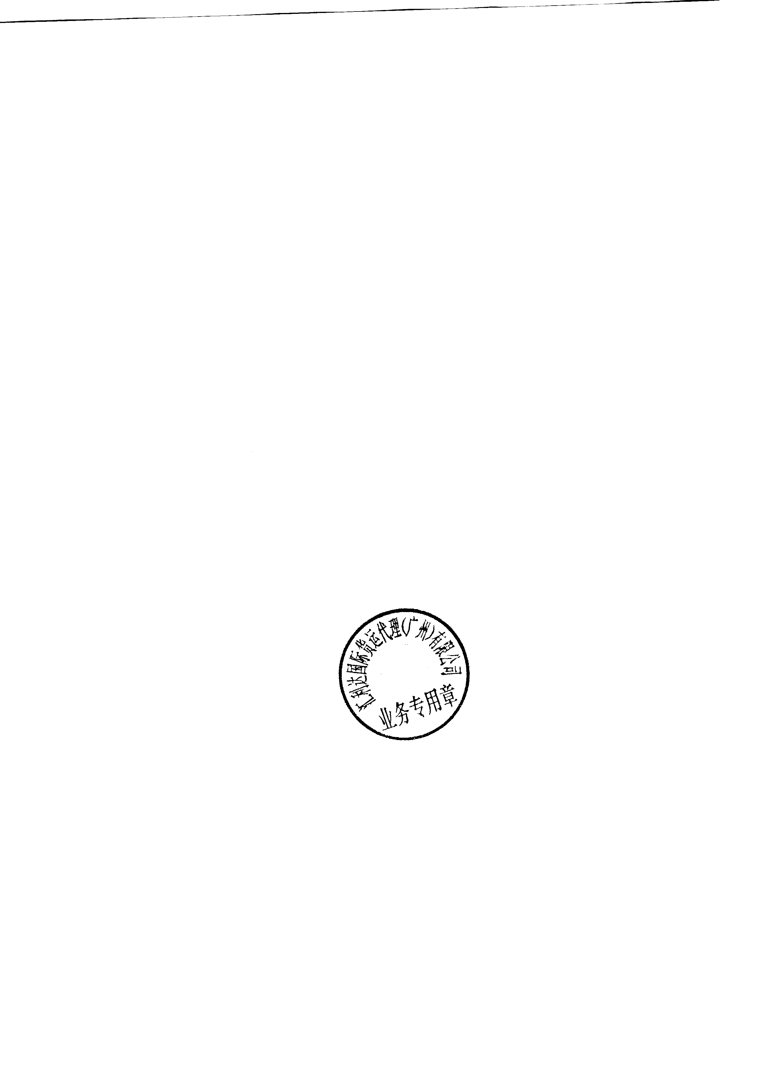
RA05670
 |  |  |  |  | SERVICE CODE
 |  |  |  |  | CFS/CFS | CFS/CY
 |  |  |  |  | CY/CY | CY/CFS
 |  |  |  |  | DOCK RECEIPT NO
REMARKS:  VENDORS SIGNATURE & CHOP |  | UNITEX INTERNATIONAL FORWARDING (GUANGZHOU) LTD  （GUANGZHOU OFFICE）

